**HVP Variant Exporter Basic User Guide – MS Access Database**

When you first load the executable – VariantExporter.exe you will be greeted with this screen.

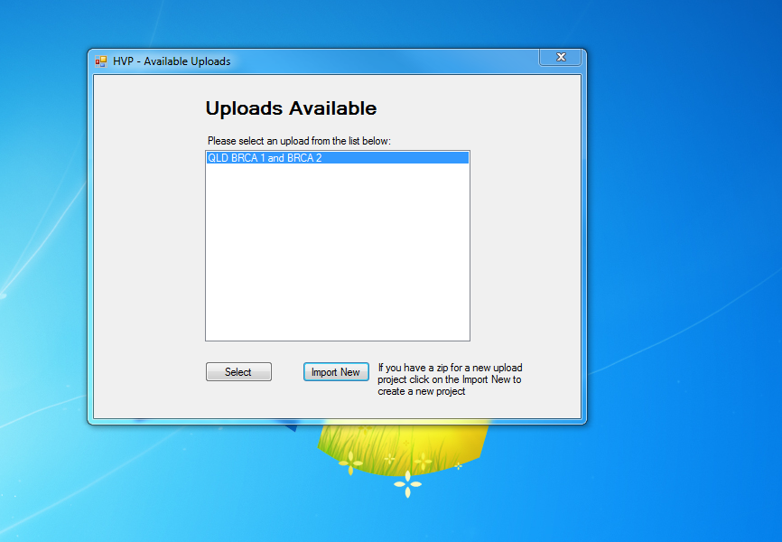

The list above shows the different number of Upload modules available. Each upload is designed specifically for a disease/gene variant data upload.

When you first receive the Variant Exporter we would have provided a preconfigured Upload session for your lab.

In the current screen above there is only one Upload module available to select that Upload you either click on the item in the list to selected it then click on the ‘Select’ button or you can double click on the list item itself.

When you have selected an Upload module you will be taken to the main window screen with two tabs. The first tab is the Data Source screen.

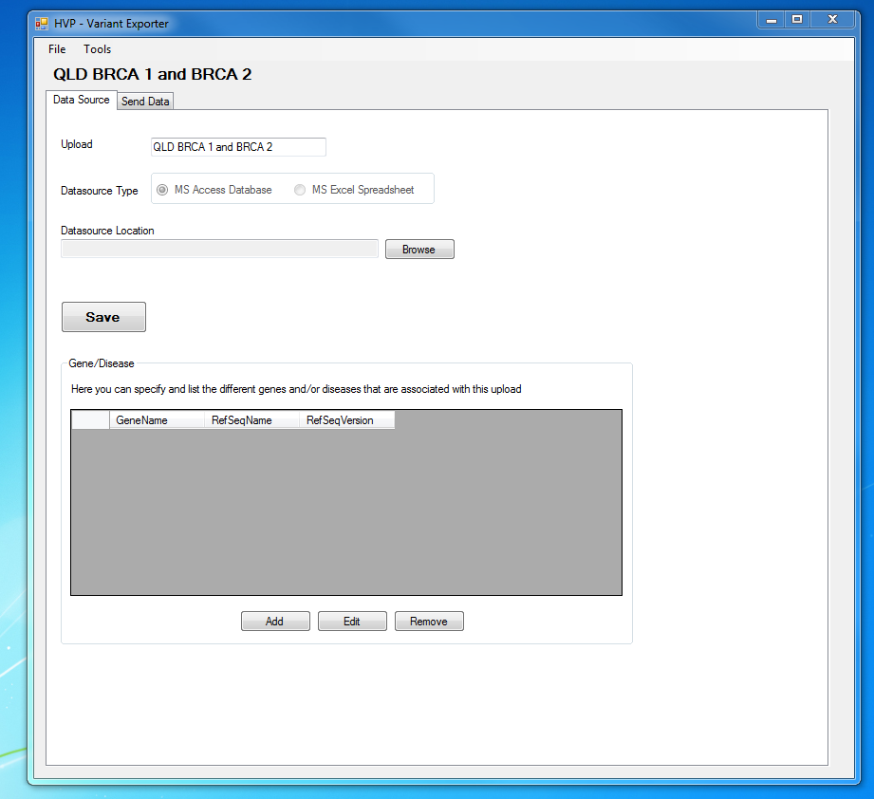

1. Upload name(Optional field) – You can specify a name for the upload module .
2. Data Source Type – This displays the type of data source where the exporter will be exporting from. The available sources are either a Microsoft Access Database or Excel Spreadsheet. The Data Source Type is dependent on the Upload module and can not be changed.
3. Data Source Location(Mandatory field) – this is the folder location of the data source on your computer such as the access database.
4. Save – this saves any changes you made in this screen such as changing the name or datasource location.
5. Gene/Disease(Optional field) – here you can specify the various different genes that are associated with this upload.

When you have specified a Data source you can go to the “Send Data” tab. From here you can load the data to be sent into the Exporter.

Y:\Desktop\Send data.tiff

To the load the data into the exporter click on the Load/Refresh Data button.

When the exporter has finished reading and validating the data from the data source you may be prompted with the following window:

Y:\Desktop\Invalid data.tiff

This window lists all the data that has not met HVP requirements or contains fields that are not valid.

From here you can find out while they are invalid, fix them and reload the data again.

Alternatively you can choose to Ignore the invalid data.

When you are ready to send the data simply click the Send Data button:

Y:\Desktop\Loaded data.tiff

You can also select which rows you want to send by manually selecting the checkbox or you can select them on with the Select All Rows button.

If successful you should get a simple message that prompts you the data has been sent.

Y:\Desktop\sent.tiff